Ranaan Meyer, Empowering the Universe to Listen (2022)

Multi Grammy winning, Emmy award winning, and Gold record Double Bassist Ranaan Meyer is most known as a founding member and performer with the string trio Time for Three, Founder and Artistic Director of Honeywell Arts Academy, and as a solo performing artist, composer and educator.

In June 2022, Time for Three released an album entitled: “Letters for the Future” on Deutsche Grammophon recording with The Philadelphia Orchestra two concertos titled “Concerto 4-3” by Pulitzer Prize and Grammy award winner Jennifer Higon and “Contact” by Pulitzer Prize winning composer Kevin Puts. Alongside Time for Three, Ranaan recorded and composed the film scoring for Robin Wright’s Focus Feature film: LAND, and co-produced and recorded on Love Renaissance: Summer Walker’s 2nd album. Tf3 has additionally performed around the world including Musik Verein, Czech Philharmonic, Schleswig Holstein Musik Festival, Hong Kong Philharmonic Orchestra, Sydney Opera House, Royal Albert Hall, Night of the Proms Tour and is in demand across North America.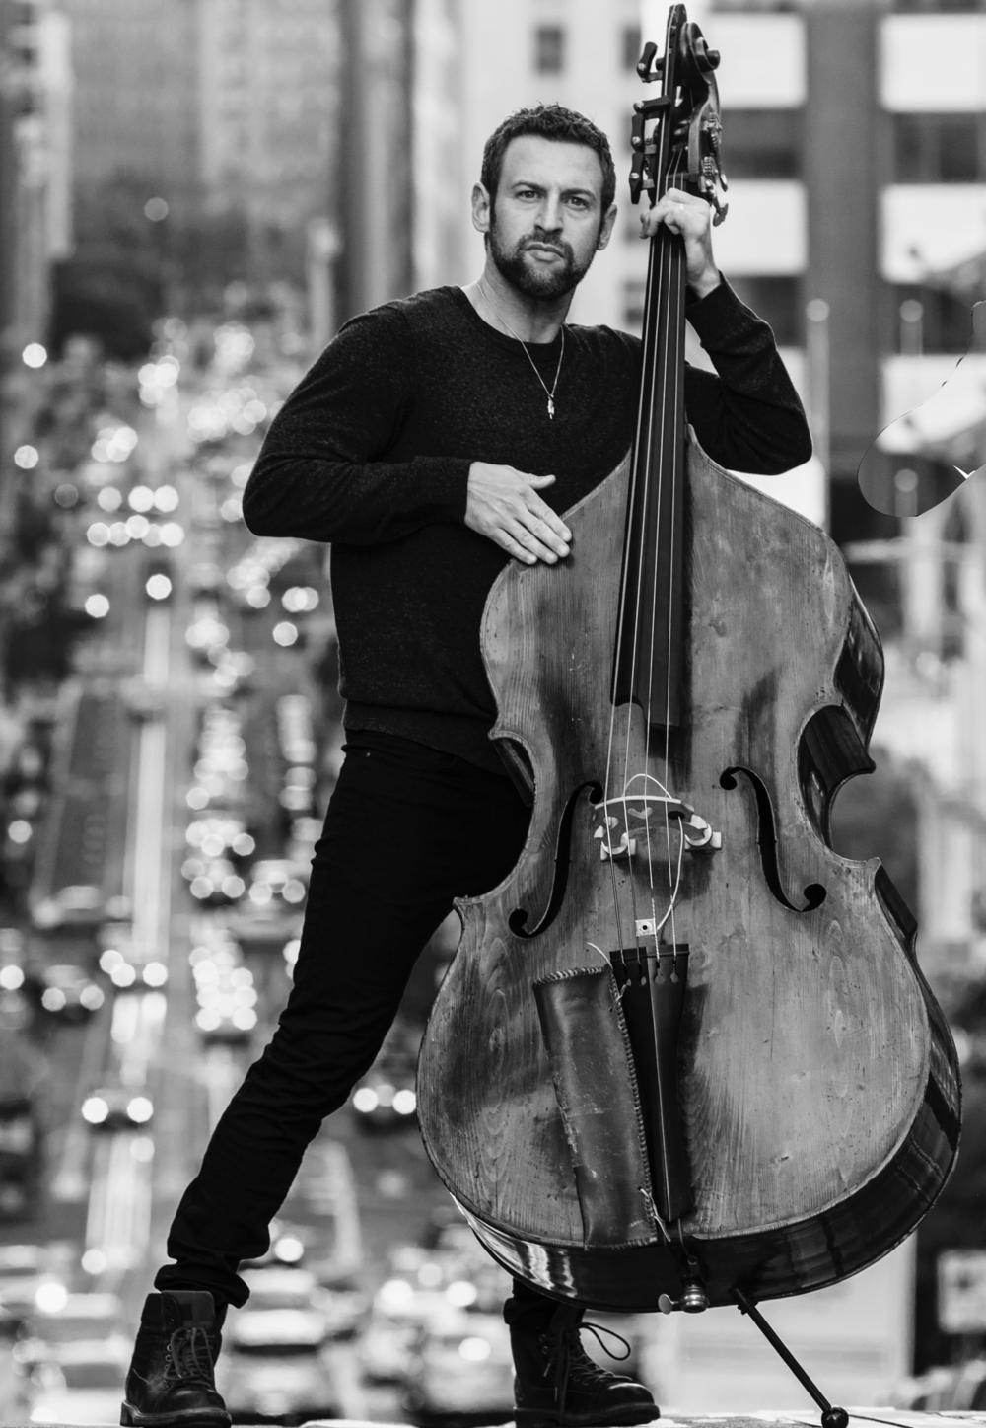

As Founder and Artistic Director of Honeywell Arts Academy Meyer has helped to empower each next generation of emerging artists through a philosophy called “sharing of knowledge”. In 2020 upon completing season 13 of Wabass Institute for the Double Bass, Artistic Director Ranaan Meyer, CEO Tod Minnich, CDO Cathy Gatchel and Program Director Emily Meyer expanded programs for the 2021 season forming the Honeywell Arts Academy. Founded in 2008, Wabass quickly became known to the bass community as a premier summer program. The Institute now approaches season 16, and Wabass alumni are worldwide spreading the “sharing of knowledge.” The evolution of Wabass into Honeywell Arts Academy is a unique emerging artist, full scholarship summer music institute held annually in Wabash, Indiana. All fueled by the same mission to foster an inclusive, supportive environment where ideas are free flowing from teacher to student and vice versa which is this philosophy referred to as the “sharing of knowledge”. As a National Endowment for the Arts grantee all programs of the Honeywell Arts Academy are full scholarships and funded purely by the generosity of charitable donations and grants.

As a soloist, Ranaan most recently composed his first concerto for double bass and orchestra entitled: ‘Concerto for My Family’ (2021) which is his homage to the people who lifted him up all along the way. He also is an alumnus of The Philadelphia Youth Orchestra, Temple Prep, Manhattan School of Music, and the Curtis Institute of Music. Ranaan co-founded Time for Three while at Curtis but prior to Time for Three's demanding touring schedule he spent several weeks per year performing and touring in the double bass section of The Philadelphia Orchestra.